Herbert Freshwater - Gunner 74664

Herbert was born 1885 in Swillington to father Thomas and mother Sarah.

He enlisted 15th April 1916 in Royal Regiment of Artillery and was posted to Great Yarmouth. He was 31 years and seven months old, working as a carpenter and living at 11 Hilderthorpe Terrace, Garforth; he wasn't married.

Burial:

Red Cross Corner Cemetery Beugny
Beugny
Departement du Pas-de-Calais
Nord-Pas-de-Calais, France
Plot: I. K. 6.

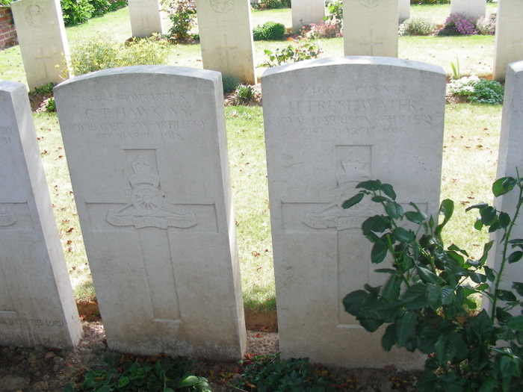

Herbert Freshwater Certificate

Father - Thomas F. Born 1832 in Haverstock Essex in 1881 Thomas was Head Gardener at Swillington House for Baronet Charles Hugh Lowther

Mother - Sarah F. Born 1847? in Islington, London

Brother - Arthur F. Born 1865 in Swillington

Brother - Edward F. Born 1866 in Swillington

Brother - Thomas F. Born 1867 in Swillington

Brother -Alfred F. Born 1869 in Swillington

Brother - George F. Born 1870in Swillington

Brother - James F. Born 1874 in Swillington

Sisiter - Mary F. Born 1876 in Swillington

Sister - Clara E. F. Born 1879 in Swillington

Sister - Emily F. Born 1880 in Swillimgton

Herbert F. Born 1885 in Swillington

